2024 Centennial Accord – Climate
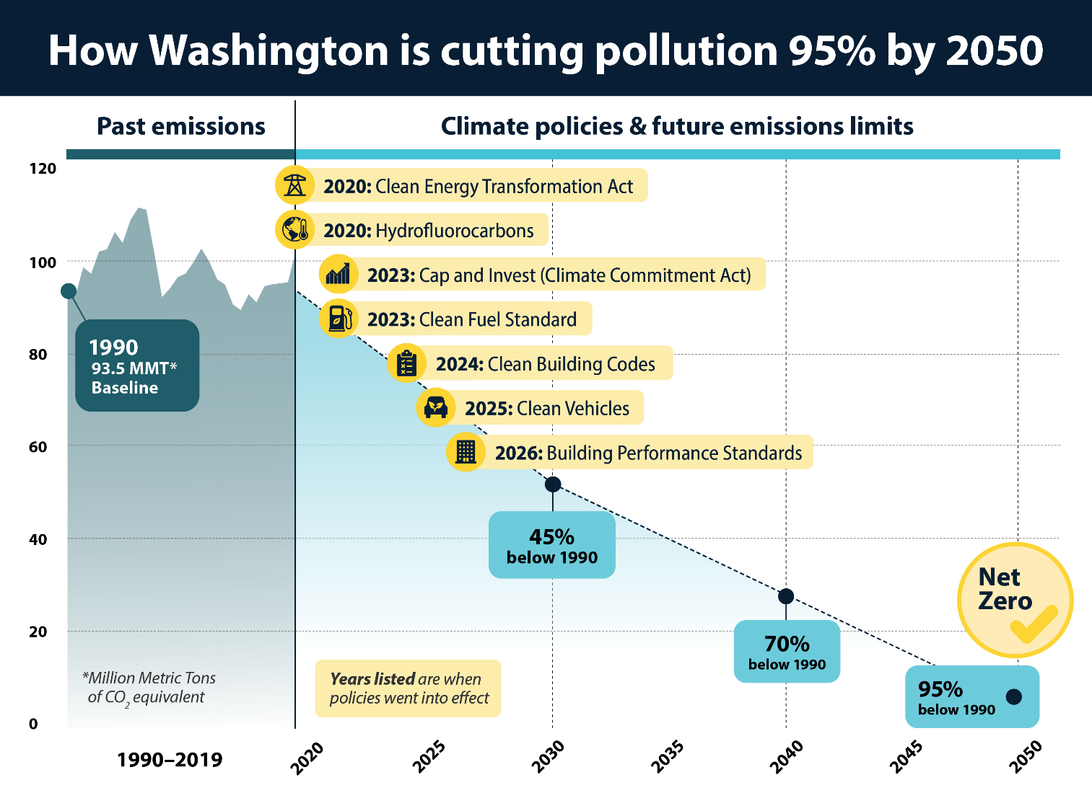
Climate Commitment Act
- Caps and reduces greenhouse gas emissions from Washington’s largest emitters through a cap-and-invest program
- Directs Ecology to reduce "criteria" air pollutants — such as ozone and particulate matter — in overburdened communities highly impacted by air pollution. All tribes are eligible to discuss participation in this initiative with Ecology.
- The state invests CCA revenues in salmon recovery, climate resilience, clean air and water, and clean, affordable energy.
- In the 2023-25 budget, the Legislature appropriated $3.2 billion of CCA revenues. $644,896,000 of that total is not effective until January 1, 2025, pending the outcome of I-2117. Another $203 million of that total is set aside for appropriation in the 2025-27 biennium for hybrid ferry construction and terminal electrification, pending the outcome of I-2117.

- At least 10% of total revenues must go to tribally-supported programs and projects. At least 35%, with a goal of 40%, must benefit vulnerable populations in overburdened communities (which includes tribal reservations).
Climate Commitment Act Investments that Benefit Tribes
- The enacted 23-25 budget includes $222 million specifically provisoed for tribes; OFM estimates that a total of $275 million will benefit tribes directly.
- There is an additional $328 million in grants that tribes are eligible to apply for.
- Together, that’s at least $550 million of funding that’s designated for tribes or tribes are eligible to apply for.
- In addition, the Legislature invested $202 million of CCA revenues (to non-tribal organizations) for salmon restoration, riparian, and habitat restoration programs and projects that are important to protect Tribes’ culture and treaty rights.

Specifically-provisoed projects
- $50 million to assist Tribes in mitigating and adapting to the effects of climate change
- $21.4 million for capacity grants to Tribes for climate/clean energy work ($5M pending outcome of I-2117, see below)
- $20 million for the Yakama Nation’s solar project
- $13.2 million for grants to tribes for input and guidance to the Environmental Justice Council and the Environmental Health Disparities Map
- $10 million for Tribal grants to develop clean energy projects
- $10 million for Tribal Transit Mobility Grants
- $10 million for Chief Leschi School HVAC
- $2.5 million for a Tribal Clean Energy Training Center
- $2.4 million for Port Gamble Shoreline Restoration
- $500,000 for cultural resource surveys to protect tribal cultural sites
Additional projects awarded as of Spring 2024 through competitive grants
- $15 million for salmon recovery/habitat/riparian restoration projects to tribes (PSAR, Salmon Recovery Riparian)
- $9.1 million for EV charging infrastructure
- $4.2 million for Tribal Carbon Offset grants
- $4.0 million for bike and pedestrian projects
- $1.5 million for Community Solar grants

$76.7 million to tribes effective on Jan 1, pending the outcome of I-2117
Granting Agency | Name | Total
Commerce | Clean Energy Community Grants
 | Lummi Indian Business Council Energy Projects | $ 7,612,000
Commerce | Local Emission Reduction Projects
 | Nisqually Indian Tribe Microgrid System | $ 8,600,000
 | Squaxin Island Tribe Blue Carbon Sequestration | $ 3,050,000
Commerce | Tribal Grants for Electric Boats | $ 5,000,000
Commerce | Muckleshoot Tribe Highway 164 Car Charging Stations | $ 500,000
RCO | Estuary and Salmon Restoration Program
 | Stillaguamish Tribe- zis a ba II Restoration/Construction | $ 1,020,000
 | Brian Abbot Fish Barrier Removal Board
 | Tulalip Tribe - Peoples Creek Fish Passage | $ 379,950
 | Tulalip Tribe - Elliott Road Barriers Design | $ 97,000
 | Tulalip Tribe - Williams Creek # 1 | $ 283,000
 | Tulalip Tribe - Pilchuck Tributary Watt Crossing | $ 126,050
Natural Resources | Quinault Legacy Forest Acquisition | $ 25,000,000
WSDOT | Puyallup Tribe - Port Electrification | $ 20,000,000
Ecology | Tribal Capacity Grants | $ 5,000,000
 | Effective January 1, 2025 (“if I-2117 is not enacted”) | $ 76,668,000

